**FACULTY OF SCIENCE, ENGINEERING**

**AND COMPUTING**

**School of Computer Science and Mathematics**

**MSc DEGREE**

**IN**

User Experience Design

CI7800 Digital Media Final Project

INTERIM PROJECT REPORT

Name: Bikash Chintak Dash

ID Number: K1934145

Project Title:  **Paprus** ([IoMT](https://www.newenglandcollegeonline.com/resources/healthcare-administration/what-is-the-internet-of-medical-things/))

Date: 20th May 2020

Supervisor: Jay Kiruthika

Project Type: BODY of CREATIVE WORK



**WARRANTY STATEMENT**

This is a student project. Therefore, neither the student nor Kingston University makes any warranty, express or implied, as to the accuracy of the data nor conclusion of the work performed in the project and will not be held responsible for any consequences arising out of any inaccuracies or omissions therein.

|  |  |  |
| --- | --- | --- |
| **No.** | **Table of Content** | **Page** |
|  | **Abstract** |  |
|  | **List of Figures** |  |
| **1** | **Introduction** |  |
| 1.2 | Literature Review |  |
| 1.3 | Main Argument |  |
| 1.4 | Previous Work |  |
| **2** | **Chapter 1** |  |
| 2.1 | Aim of Project |  |
| 2.2 | Design Aim |  |
| 2.3 | Objective of Project |  |
| **3** | **Chapter 2** |  |
| 3.1 | Diabetics |  |
| 3.2 | Eating Disorder |  |
| 3.3 | Fitness |  |
| **4** | **Chapter 3** |  |
| 4.1 | Product Ergonomics |  |
| 4.2 | Daily Tasks/ Challenges |  |
| 4.3 | Design Process |  |
| **5** | **Chapter 4** |  |
| 5.1 | Research Method |  |
| 5.2 | Insights/Feedback |  |
| 5.3 | Analytics |  |
| **6** | **Chapter 5** |  |
| 6.1 | Persona |  |
| 6.2 | User Journey Map |  |
| 6.3 | Empathy Map |  |
| **7** | **Chapter 6** |  |
| 7.1 | User Case Study |  |
| 7.2 | Information Architecture |  |
| 7.3 | Sketch Prototyping |  |
| **8** | **Chapter 7** |  |
| 8.1 | Colour Code |  |
| 8.2 | Low-Fidelity Wireframe |  |
| 8.3 | Usability Testing |  |
| **9** | **Chapter 8** |  |
| 9.1 | High-Fidelity Wireframe |  |
| 9.2 | Prototyping |  |
| 9.3 | Usability Testing |  |
| **10** | **Chapter 9** |  |
| 10.1 | Discussion & References |  |
| 10.2 | Appendix |  |

**Abstract**

Begun in 1501BC the study of medical science was proposed by author named Derin a most rational and scientific terms. The book comprises of 48 major cases of treatment and surgery mentioned in details. The vast majority of the papyrus is concerned with trauma and surgery on the verso (Sullivan 1996). Reflection in today’s term the Internet of Medical Things (IoMT) is a term that describes all medical devices connected to a healthcare provider’s computer system through the internet. These devices can generate, collect, analyse and transmit healthcare data. Devices in IoMT include wearables, remote patient monitoring, sensor-enabled devices are the primary interaction with the user to extract precise data to understand and study recovery and health equilibrium. The major devices to be used in the solution are Smart Jars (to monitor users diet), Smart Bins (to monitor the food discarded) and Smart Wearables. The solution focusses to log the user diet and monitor the health of the user for a healthy lifestyle or recovery towards it. care. An overview of smartphone uses in physical & behavioural health care and discuss options for integrating mobile technology into clinical practice. The report will further outline the discussion of limitations, practical issues and recommendation.

Keywords: smartphone, mobile device, mHealth, apps, technology, IoMT devices

1. **Introduction**

Major problem towards the health sector is an irregularity in food habits. Some researchers suggest “circadian rhythms” can be disturbed due to the irregular food habits and skipping of meals. They have a higher risk of type 2 diabetes, high blood pressure and obesity. They also quoted that 80% of central Europe are likely to be affected by social jetlag. Though the major focus for this project was towards the eating disorder, though the disorder’s cause is not specific the process of treatment is well-tailored. The treatment needs a thorough monitoring of your diet and logging your diet and emotion using an application which is accounted by a clinician or your local GP. The idea was first discussed in previous specialisation topic [*Grossify*](http://www.kebfourtwo.com/grossify.html)which can be referred for in-depth understanding.

The

* 1. **Literature Review**

To develop a product solution for a multi-disciplinary mHealth Application integrated with Internet of Medical Things (IoMT).

The product solution focusses on keeping a track of diet in real-time and log quantity of food cooked for each meal, and update the user profile. Where user can integrate smart watch or any health application to enhance the accuracy of body calories gained and lost. The product also focusses on binding the user profile with clinician’s and Nutrition and dietetics technicians, registered (NDTRs).

* 1. **Main Argument**

Smart wearable devices has enormous potential to integrate with technology to study the human body closely with the most real-time and accurate information recorded to study and analyse users statistics. As we deal with three major problems to be discussed in the project those are Eating Disorder, Diabetics and Fitness of a user.

* The major challenge is making the applications in seamless across all platform to make the data flow convenient and easy for the users to trigger actions and visualize the respective data.
* To design the interface for eating disorder patient those needs to log the emotions during any activity to log a session.

**[Arguments on Diabetics and Other users’ needs are generalized so needs further research to conclude the elements of interactions (to be done later..)]**

* 1. **Previous Works & Dependency**

The previous work is based on the principle to track the food items form the kitchen inventory and other storage places. The devices will give the real-time information for the quantity of food reduced for cooking and log in as the standard quantity the user intakes in the food session. The application was also framed to generate information enough for BED (Binge Eating Disorder). It also included actions to integrate the components (Smart Jars) with the application. The application lacked to cross verify the emotions of the user with a real-time value and the user input.

1. **Chapter 1** 
   1. **Aim of Project**

To develop a product solution for a multi-disciplinary mHealth Application integrated with Internet of Medical Things (IoMT).

The product solution focusses on keeping a track of diet in real-time and log quantity of food cooked for each meal, and update the user profile. Where user can integrate smart watch or any health application to enhance the accuracy of body calories gained and lost. The product also focusses on binding the user profile with clinician’s and Nutrition and dietetics technicians, registered (NDTRs).

**2.2 Design Aim:**

To design an application environment for minimal interaction to log emotions and check alerts using a smart watch.

To design a mobile application to visualize and manage the health information and food inventory in real-time.

To design a dashboard for the clinicians to manage the patients’ and monitor the health in real-time.

**2.3 Objective**

The objective of the solution is to provide the accuracy in food intake

* Real-time monitoring
* Analyse the progress of the user
* Predict the user behaviour with respect to food cycle
* Maintain a clean diet threshold
* Log of dietary for clinician purpose
* Log of emotions
* Maintaining diet consistency
* Monitor sugar intake
* Monitory groceries

The motive that drives the application principles are well defined with purpose certain objective may not be reflected in the application which are not necessary but can be a part of future work if the application is developed for a service based products.

1. **Chapter 2**

**3.1 Diabetics:**

The focus of this product for CGM (Continuous Glucose Monitoring) for both Type 1 & Type 2. Both type of diabetes is diverse with cause and root, but which binds the solution is lack of insulin which disturbs the sugar (glucose) level in blood.

Type 1: In this case the insulin secreted by pancreatic gland is destroyed by body’s immune system. A disease which is autoimmune by the body itself and is common among the youngsters and children’s. The cure for this is yet to be discovered and the cause is yet to be engineered. Complication in a long run can push the person to seizures, comas, kidney damage and cardiovascular disease.

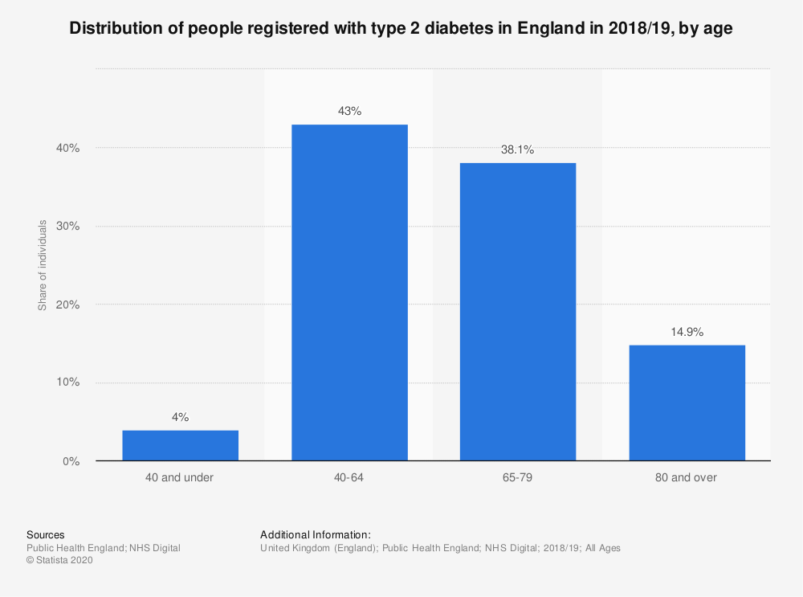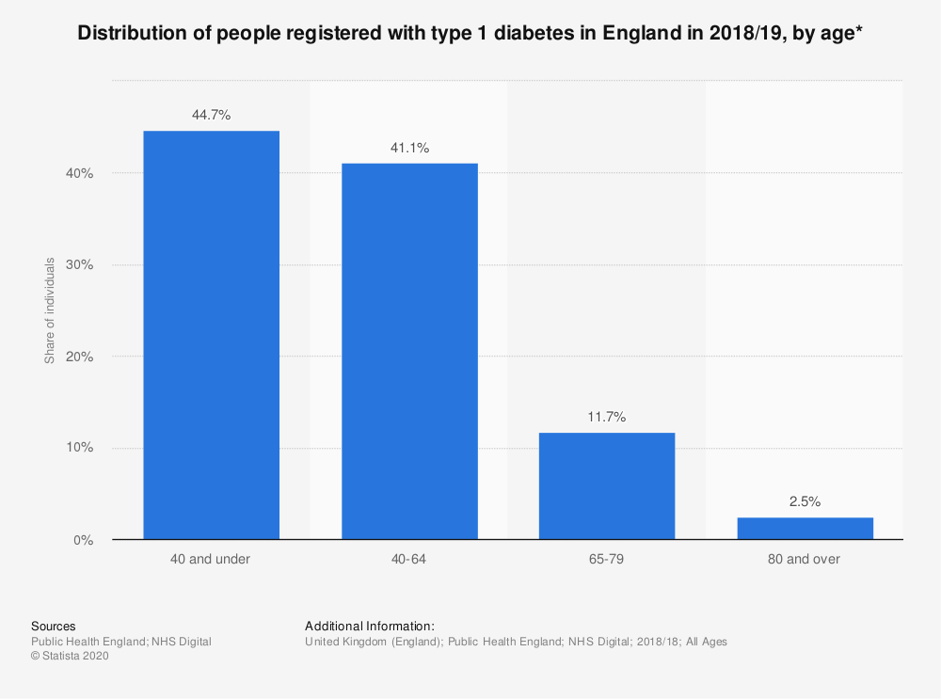Type 2: The sugar (glucose) level in blood is quite high which results to wreaking the blood vessels all over the body and create complication. The complications can lead to tiredness, blurred vision, slow healing, obesity etc.

The frequency of CGM is higher for type 1 compared to type 2, to define the target audience we have 44.7% of people under 40 are affected with type 1 (left) while 41% are affected with age group of 40 – 64. Again looking at the stats for type 2 (right) the under 40 age group is the least affected compared to 40 – 64 which is 43%. This gives us clear idea that the age group the solution is looking at is 40 – 64 which has a difference of 1.9% between type 1 & type 2. Looking at both the type of diabetes the severity is more for the case of type 1 diabetes.

3.1.1 Daily Task for Type 1 diabetes: (Content to be replaced with Chapter 3 (4.2))

* Insulin Dose for long time period
* Periodic blood test (in a day)
* Carbohydrate count for each meal
* Post meal insulin shot

3.1.2 Process for Diabetics: 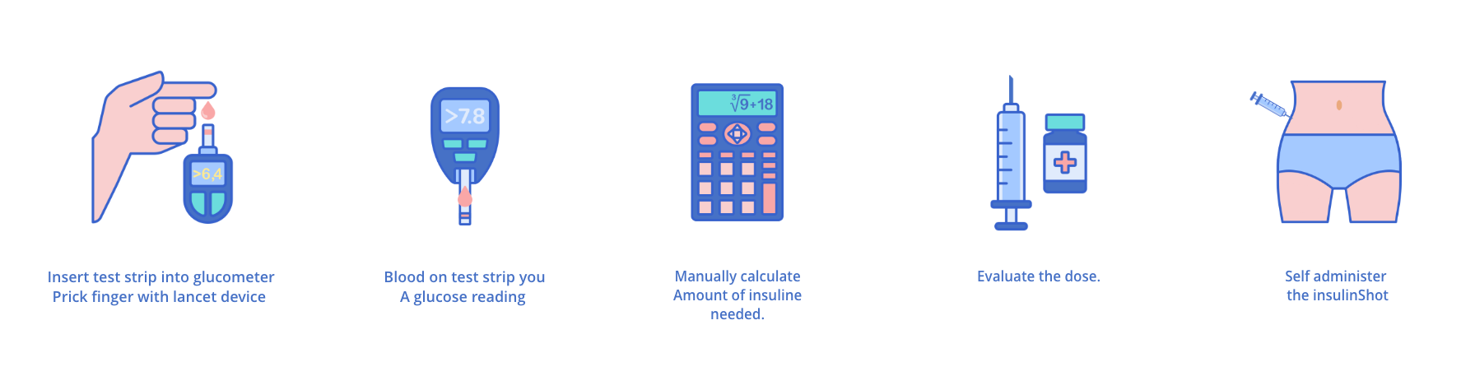

To evaluate the total amount of required insulin needed the factors are:

* Carb to insulin ratio
* Corrective insulin amount
* Insulin amount in the body

3.1.2 Formulas:

Carb Insulin: insulinCarb = carbAmount / carbFactor

Correction Insulin: insulinCorrection = (bgReading — bgTarget) / sensitivityFactor

Insulin OnBoard: insulinPerHr = insulinPrev / 3

(Note: 3 is the number of hours it takes insulin to run its course)

timeElapse = timeCurrent — timePrev

(Note: if timeElapse is >= to 3 insulinOnBoard = 0)

timeLeft = 3 — timeElapse

insulinOnBoard = insulinPerHr * timeLeft

Total Insulin take: insulinTotal = (insulinCarb + insulinCorrection) — insulinOnBoard

3.1.3 Research:

The data to be reflected should be analysed and studied before deciding the UI content and the relevance of the data for the user. The best product to mirror is Dexcom G6 CGM (Continuous Glucose Monitor) the technology can be segmented in three parts such as sensor, transmitter and receiver.

Below is an example of data collected from the sensor:

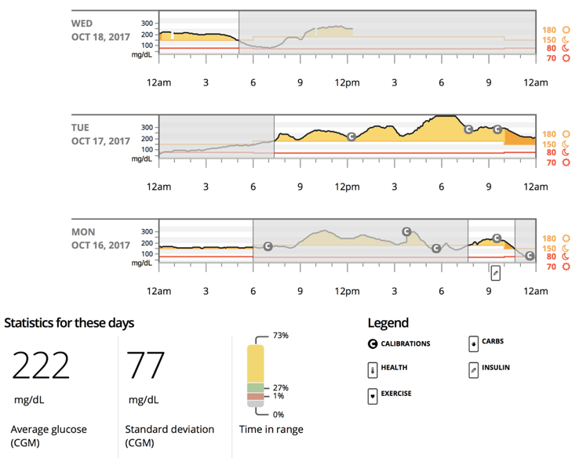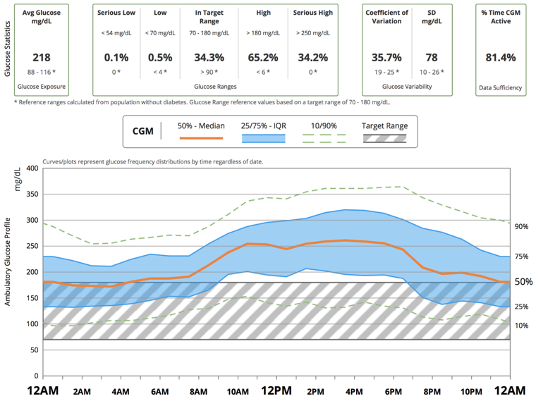

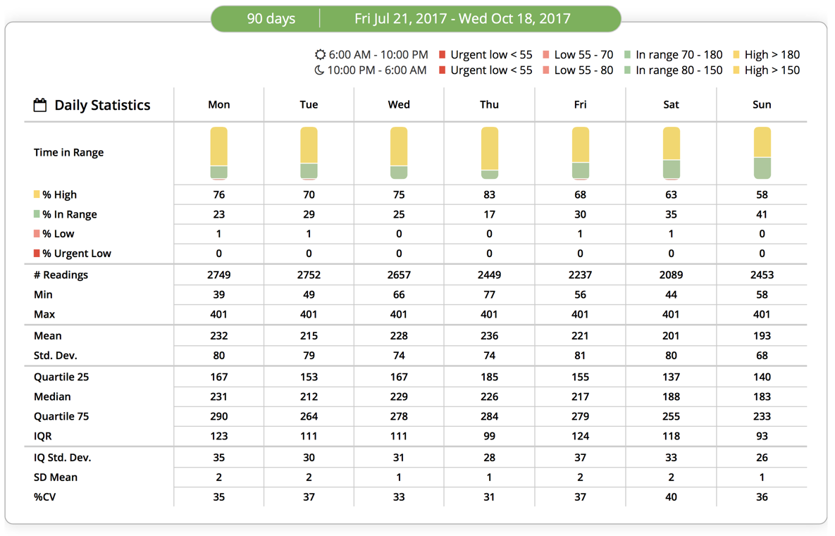Glucometer:

Findings:

* The files are not convenient to access as they need to be downloaded for the web portal.
* The reports are not well organised or labelled in a readable format.
* No comparison, just data sheet for a session (day/time).